INSTRUCTION MANUAL FOR DRY BATH DSD-100 & DSD-200
(1)
(2)
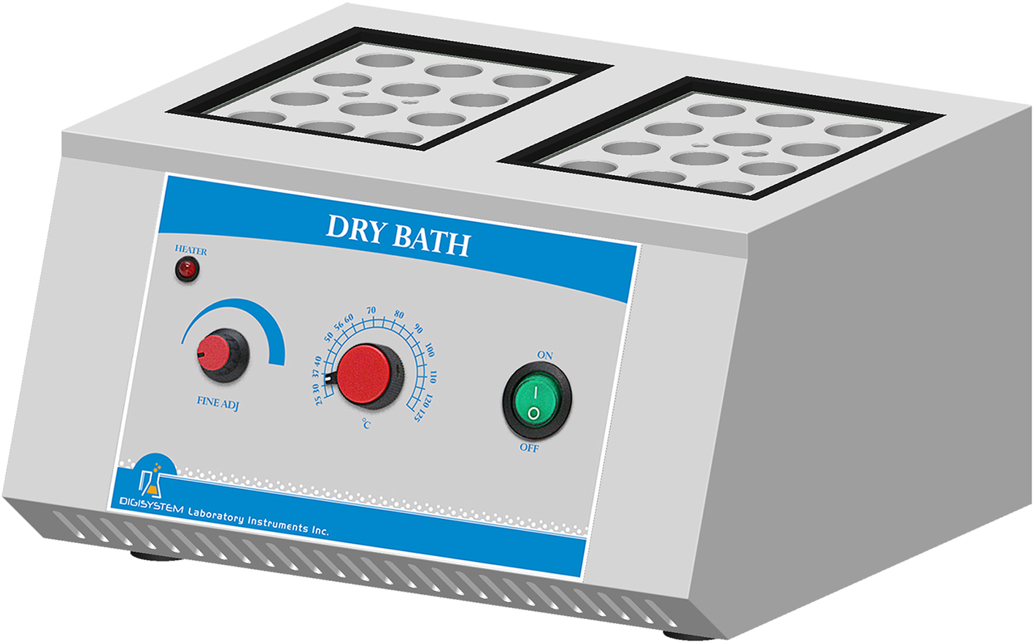
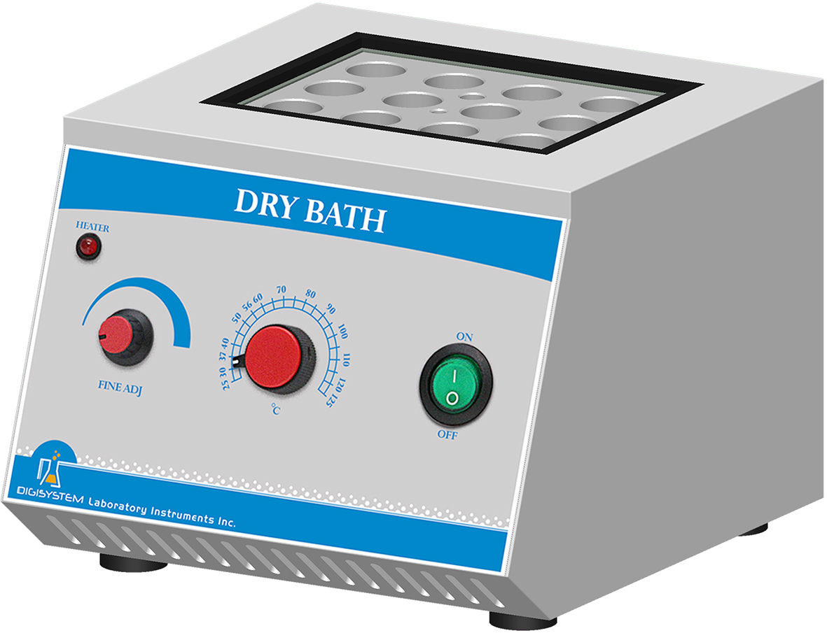

(5)
(5)
(6)
(3)
(4)
(6)
(3)
(4)

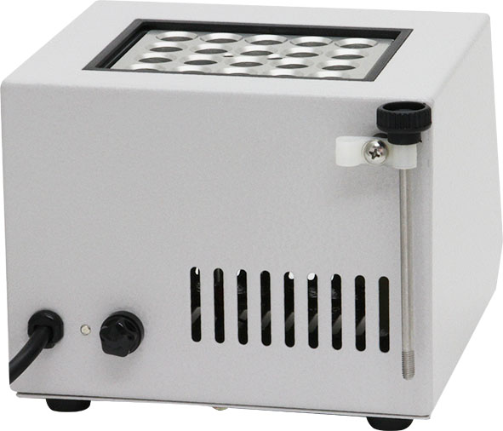
Block lifter
(1) Thermometer Holder (2) Block
(3) Power Switch (4) Temperature Controller
(5) Heater Lamp (6) Fine Adjuster

Warnings:
* The surface is hot. Do not touch.
* Do not put any objects on the top of the instrument.
* Please keep the environment ventilated.

Steps:
1. Connect with power supply. Please make sure the power voltage is the same as the voltage shown on the label back of the machine.
2. Insert the thermometer into the “Thermometer holder” (1).
3. Place the “Power Switch” (3) at “ON” position.
4. Adjust “Temperature Control” (4) to the required Temperature scale, and then “Heater Lamp” (5) lights up. When the temperature reaches the setting value, “Heater Lamp” becomes off.
5. Check the Thermometer if the temperature is the same as the required temperature. If the thermometer temperature is under the required temperature, turn “Fine Adjuster” (6) clockwise slightly; if the thermometer temperature is over the required temperature, turn “ Fine Adjuster” (6) counterclockwise slightly. Check and adjust until the thermometer temperature is the same as the required temperature.
6. Insert the test tubes with specimen into the “Block” (2)

Maintenance and care:
Keep the machine clean all the time, so no routine maintenance is required. Cleaning can be done with a damp cloth. Avoid the use of solvents as they may damage the product.

Circuit Diagram:
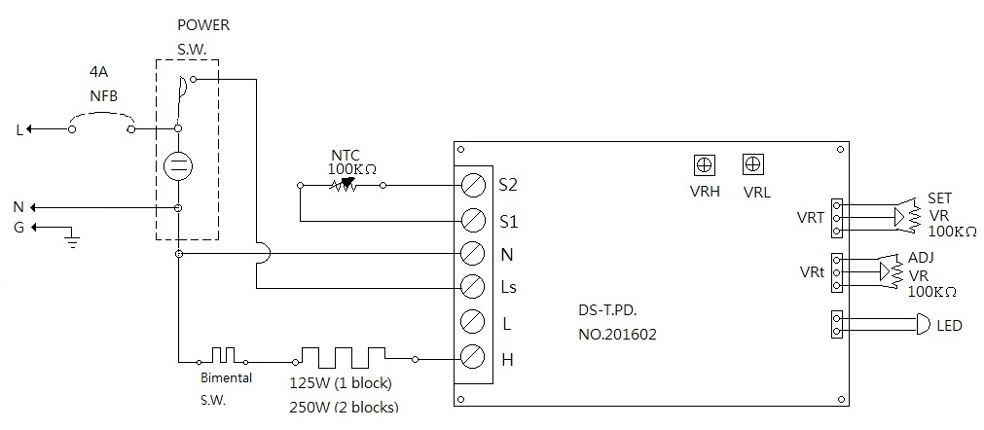

Troubleshooting Guide
Caution: Always disconnect the power cord before troubleshooting.
Trouble | Cause | Remedy
Instrument inoperative | Power cord not connected to outlet. | Plug instrument in.
Instrument inoperative | Dead power output. | Change to different output.
Instrument inoperative | Fuse is burnt. | Change a new fuse, and check if the voltage is correct (refer to the back label).
Instrument inoperative | Electronic element broken | Contact your distributor for repair.
Instrument inoperative | Power switch is broken | Contact your distributor for repair.
Fuse is burnt | Voltage is not correct. | Check and change to the correct voltage.
Fuse is burnt | Heater is broken. | Contact your distributor for repair.
Fuse is burnt | PC board is broken. | Contact your distributor for repair.
Temperature can’t be controlled. | Temperature controller is broken. | Contact your distributor for repair.
Temperature can’t be controlled. | Heater is broken. | Contact your distributor for repair.
Temperature can’t be controlled. | PC board is broken. | Contact your distributor for repair.
Instrument can’t heat | Heater is broken. | Contact your distributor for repair.
Instrument can’t heat | PC board is broken. | Contact your distributor for repair.

